

|  |  |
| --- | --- |
| Learning document for | **HP ED Services** |

**Project Details**

|  |  |  |  |
| --- | --- | --- | --- |
| Project Name: | HP ED services | Project Manager / Email ID: | Sameer.chandna@wipro.com |
| Authors: | Divya Ramesh  Pankaj Sinha |  |  |

|  |  |  |  |  |
| --- | --- | --- | --- | --- |
|  |  |  |  |  |
| **Prepared by/Date (PM)** |  | **Reviewed by/Date (SQA)** |  | **Approved by/Date (DM)** |

**List of Reference Documents**

|  |  |
| --- | --- |
| **Name** | **Version No.** |
| 1. Learning document | https://hp.sharepoint.com/teams/NewIT/Partners/Wipro/Shared%20Documents/Forms/AllItems.aspx?id=%2Fteams%2FNewIT%2FPartners%2FWipro%2FShared%20Documents%2FED%20services%2FLearning%20document |
| 1. Test Plan | https://hp.sharepoint.com/:w:/r/teams/NewIT/Partners/Wipro/Shared%20Documents/ED%20services/Test%20Plan/HP_ED_Testplan_V1.0.doc?d=wd2e25c1915a0422697cf89cf8558c8e8&csf=1&e=69xvAQ |
| 1. Test case | https://hp.sharepoint.com/teams/NewIT/Partners/Wipro/Shared%20Documents/Forms/AllItems.aspx?id=%2Fteams%2FNewIT%2FPartners%2FWipro%2FShared%20Documents%2FED%20services%2FTest%20case |
| 4. |  |

**Table of Contents**

1. Introduction 5

2. Scope of Testing 5

Features/Functionalities to be tested 5

3. Testing Approach 5

4. API in scope 5

4.1. Manage: 5

4.2. Learn: 6

4.3. API Docs: 6

5. Manage API 6

5.1. /manage/v1/orgchart -List of branches of given or root level: 6

5.1.1. **Data creation in Docebo UI:** 6

5.1.2. **API validation:** 7

5.1.3. **Database validation** 9

5.2. /manage/v1/orgchart/{branch_id}/users - Retrieve information about a branch's users. 10

5.2.1. **Data creation in Docebo UI** 10

5.2.2. **API Validation:** 11

5.3. /manage/v1/orgchart/{branch_id}/users -search for "Retrieve information about branch user" 11

5.3.1. **API Validation** 11

5.3.2. **Database validation:** 12

5.4. /manage/v1/user- Returns list of Users 13

5.4.1. **Data creation in Docebo UI:** 13

5.4.2. **API Validation:** 14

5.4.3. **Database validation:** 15

5.5. /manage/v1/user/{user_id} 16

5.5.1. **Data creation in Docebo UI:** 16

5.5.2. **API Validation:** 17

5.5.3. **Database validation:** 18

5.6. Manage/v1/user_fields 19

5.6.1. **Data creation in Docebo UI:** 19

5.6.2. **API Validation:** 20

5.6.3. **Database validation:** 20

6. Learn API 21

6.1. /learn/v1/location 21

6.1.1. Data creation in Docebo 21

6.1.2. **API Validation** 23

6.1.3. **Database Validation** 23

7. Docs API 38

7.1. /iltsessions/listAction 38

7.1.1. **API Response Validation** 38

7.1.2. **Database Validation** 39

7.2. /iltsessions/ilt_course_status_count 39

7.2.1. **API Response Validation** 40

7.2.2. **Database Validation** 40

7.3. /location/countSessionsByLocation 41

7.3.1. **API Response Validation** 41

7.3.2. **Database Validation** 42

7.4. /learningplan/enrollments 42

7.4.1. **Data creation in Docebo:** 42

7.4.2. API Validation 43

7.4.3. Database validation 43

7.5. /report/listReports 44

7.5.1. **Data creation in Docebo** 44

7.5.2. **Database validation** 46

7.6. /report/user 47

7.6.1. API Validation 47

7.6.2. **Database validation** 48

7.7. /report/countRows 48

7.7.1. **Data creation in Docebo** 48

7.7.2. API Validation: 50

7.7.3. Database validation: 50

7.8. /report/ExtractRows 51

7.8.1. **Data creation in Docebo** 51

7.8.2. API Validation: 52

7.8.3. Database validation: 53

7.9. /stat/getGenericUserStat 53

7.9.1. API Validation: 53

7.9.2. Database validation: 54

7.10. /stat/getGenericPlatformStat 55

7.10.1. API Validation: 55

7.10.2. Database validation: 56

7.11. /stat/getGenericUserStat 56

7.11.1. API Validation: 56

7.11.2. Database validation: 57

7.12. User/group_association 58

7.12.1. Data creation in Docebo 58

7.12.2. API Validation: 58

7.12.3. Database validation: 59

8. Additional Information 59

# Introduction

Currently View central is providing the LMS capabilities for external partners and end users through Ed services. HP decided to changeover LMS View Central with LMS Docebo.

# Scope of Testing

## Features/Functionalities to be tested

* UI validation
* API validation
* Database testing

# Testing Approach

This document describes

* How we are creating Test data from Docebo UI
* How to validate the API Response
* How to validate Database and ensure the API response is loaded correctly in Database

# API in scope

Below are the API which are in scope for testing

## Manage:

|  |
| --- |
| /manage/v1/orgchart |
| /manage/v1/orgchart/{branch_id}/users |
| /manage/v1/user |
| /manage/v1/user/{user_id} |
| /user/fields |

## Learn:

|  |
| --- |
| /learn/v1/location |
| /learn/v1/courses |
| /learn/v1/courses/{course_id} |
| /learn/v1/catalog |
| /learn/v1/catalog/{catalog_id} |
| /learn/v1/lp |
| /learn/v1/lp/{lp_id} |
| /learn/v1/enrollments |
| /learn/v1/survey/[object_id]/answer |

## API Docs:

|  |
| --- |
| /learningplan/enrollments |
| /iltsessions/listAction |
| /iltsessions/ilt_course_status_count |
| /location/countSessionsByLocation |
| /report/listReports |
| /report/user |
| /report/countRows |
| /report/extractRows |
| /stat/getGenericUserStat |
| /stat/getGenericPlatformStat |
| /user/group_associations |

# Manage API

In Manage API we cover below API in details with testing flow.

## /manage/v1/orgchart -List of branches of given or root level:

### **Data creation in Docebo UI:**

* Login to Docebo UI
* Navigate to Settings->User and click on + sign to add new branch

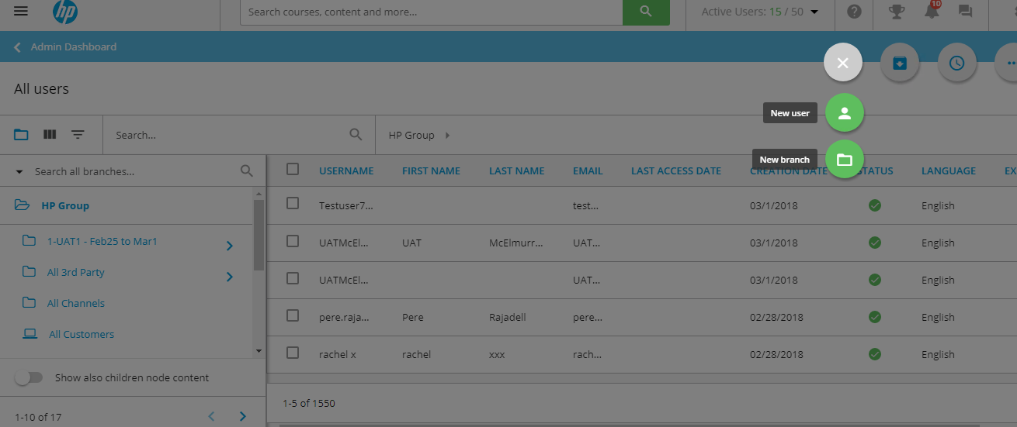

New branch creation

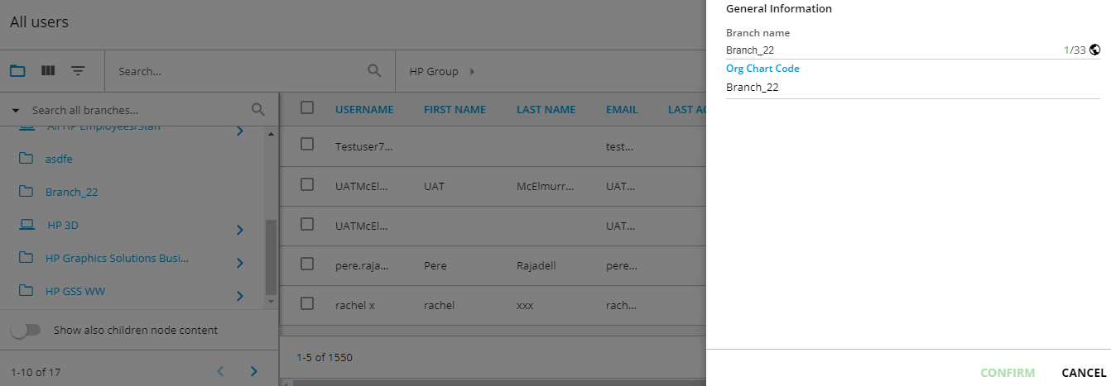

### **API validation:**

* Navigate to API testing tool
* Select , Services: Manage and Token: Enter valid token
* Search for /manage/v1/orgchart

Hit try button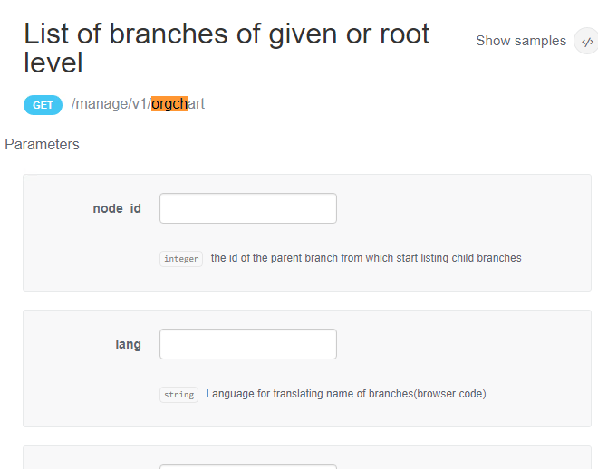

Validate the response and search for newly created branch is available in the response

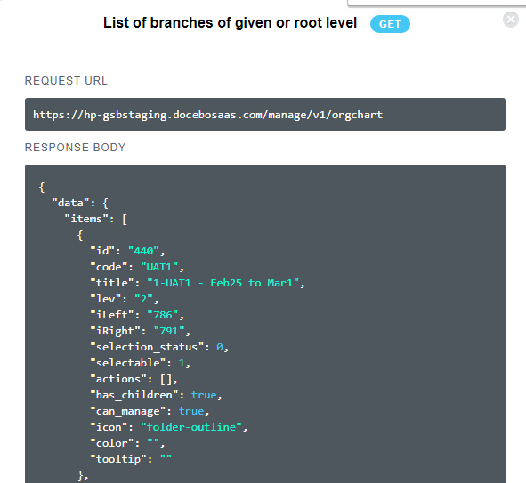

Attached sample json response for complete file:



### **Database validation**

* Login to DB server
* In SSMS , validate the newly added records in [EDServices_IC].[dbo].[IC_Orgchart]table
* User list which was available in api response should be available in [EDServices_IC].[dbo].[IC_Orgchart]table

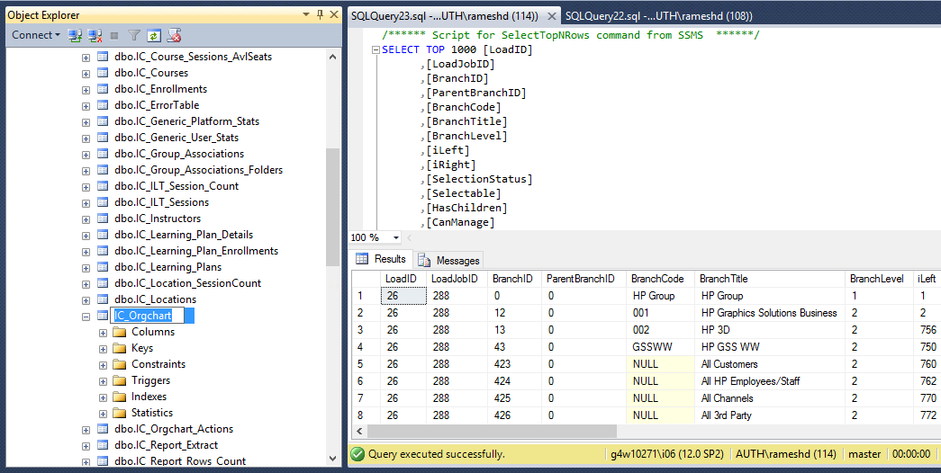

## /**manage/v1/orgchart/{branch_id}/users - Retrieve information about a branch's users.**

### **Data creation in Docebo UI**

1. Login to Docebo UI
2. Navigate to Settings->User and click on + sign to add new USER
3. Add user with all the detail
4. Select the Branch in which the user need to be added
5. Confirm and save the detail

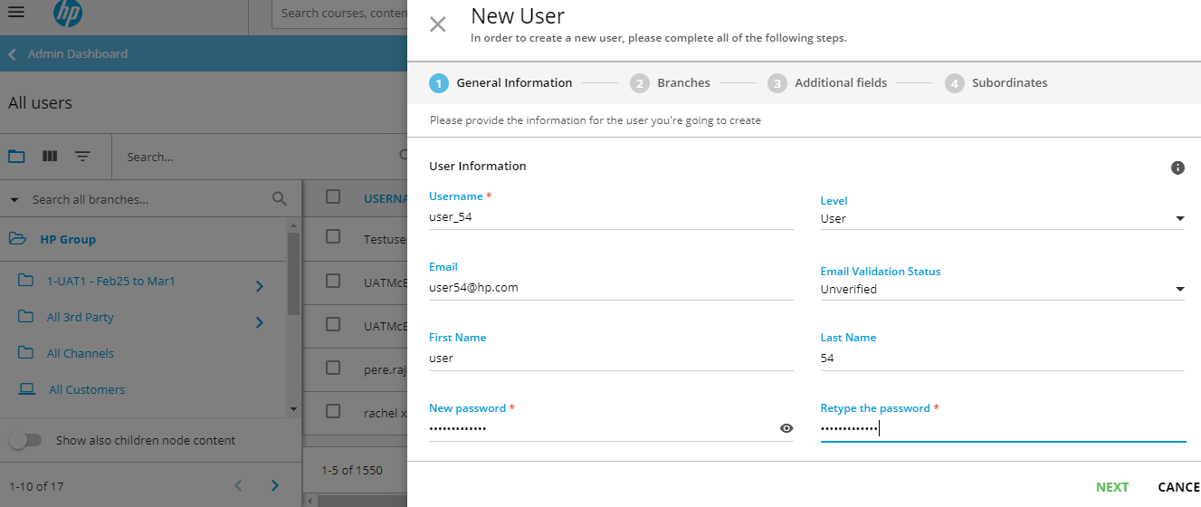

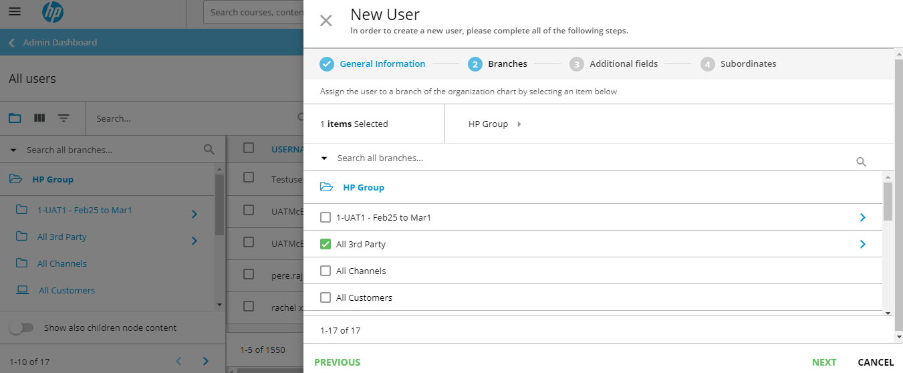

### **API Validation:**

* Navigate to API testing tool
* Select , Services: Manage and Token: Enter valid token

## /manage/v1/orgchart/{branch_id}/users -search for "Retrieve information about branch user"

### **API Validation**

* Search for branch from /manage/v1/orgchart and get the id , provide the id in /manage/v1/orgchart/{branch_id}/users Hit Try button and validate the data

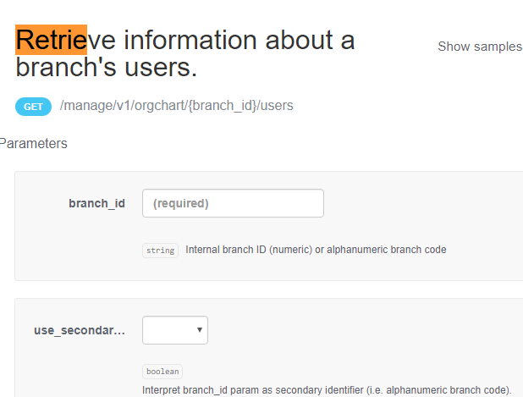

Sample api response for branch_id/users



### **Database validation:**

* Login to DB SSMS and validate the newly added records in [EDServices_IC].[dbo].[IC_Branch_users]table

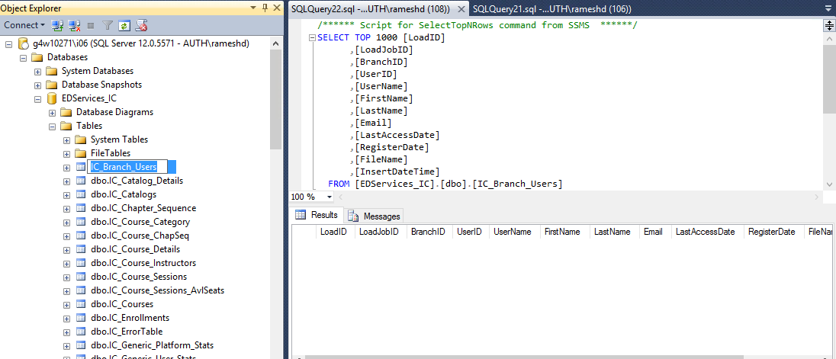

## /manage/v1/user- Returns list of Users

### **Data creation in Docebo UI:**

* Login to Docebo UI
* Navigate to Settings->User and click on + sign to add new USER
* Add user with all the detail
* Select the Branch in which the user need to be added
* Confirm and save the detail





### **API Validation:**

* Navigate to API testing tool
* Select , Services: Manage and Token: Enter valid token
* search for " Returns list of Users"
* Validate the newly created user available in response

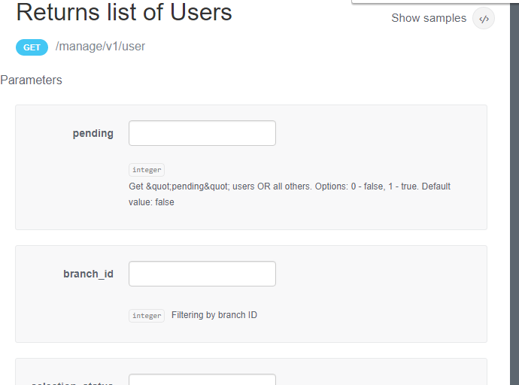

Sample api response for branch_id/users



### **Database validation:**

Login to DB SSMS and validate the newly added records in [EDServices_IC].[dbo].[IC_Users] table

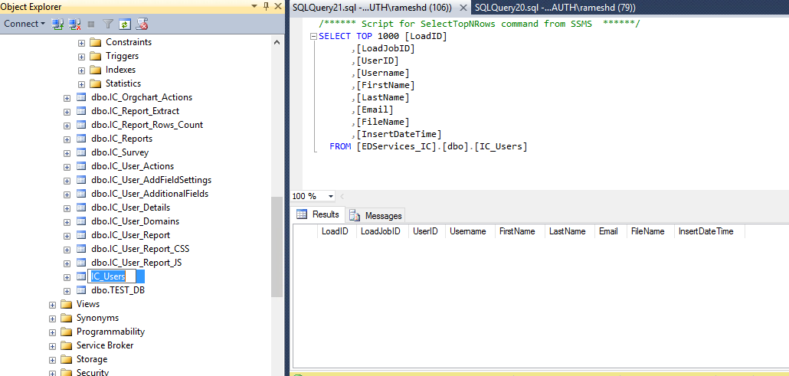

## /manage/v1/user/{user_id}

### **Data creation in Docebo UI:**

* Login to Docebo UI
* Navigate to Settings->User and click on + sign to add new USER
* Add user with all the detail
* Select the Branch in which the user need to be added
* Confirm and save the detail





### **API Validation:**

* Navigate to API testing tool
* Select , Services: Manage and Token: Enter valid token
* Search for “view user info”
* Search for newly created user from /manage/v1/user and get the id , provide the id in /manage/v1/user/{user_id} Hit Try button and validate the data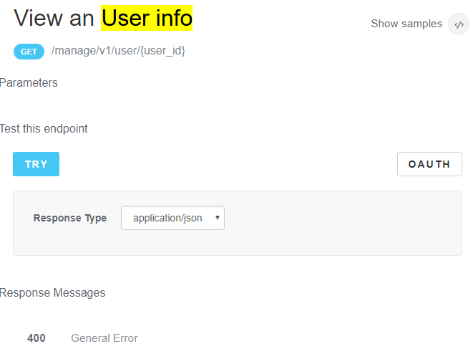

Sample api response for users



### **Database validation:**

Login to DB SSMS and validate the records in [EDServices_IC].[dbo].[IC_User_Details]table

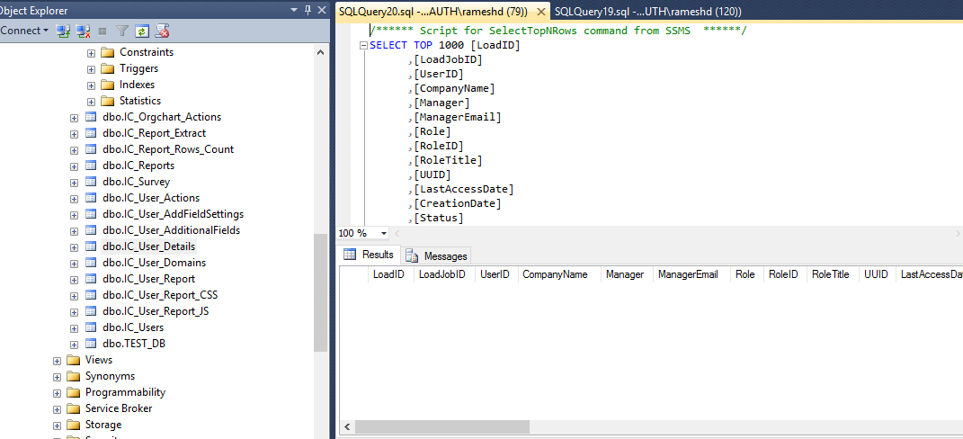

## Manage/v1/user_fields

### **Data creation in Docebo UI:**

* Login to Docebo UI
* Navigate to Settings->User and click … and Edit the user, Move to additional field section
* Note down the additional fields

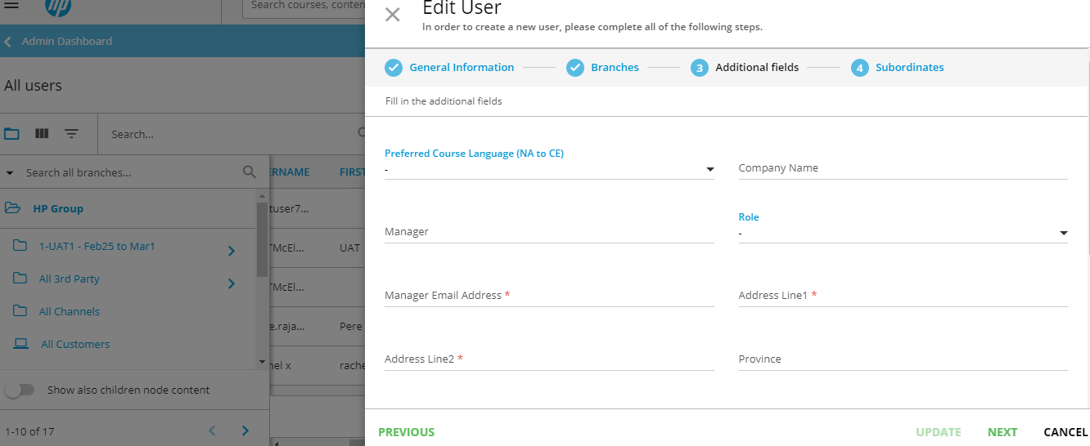

### **API Validation:**

* Navigate to API testing tool
* Select , Services: Manage and Token: Enter valid token
* Search for “manage/user/v1/user_fields”
* Compare the noted additional fields are displaying correctly in the response

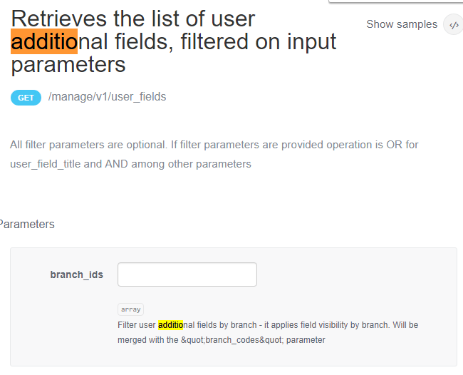

Sample api response for users



### **Database validation:**

Login to DB SSMS and validate the records in [EDServices_IC].[dbo].[IC_User_AdditonalFields]table

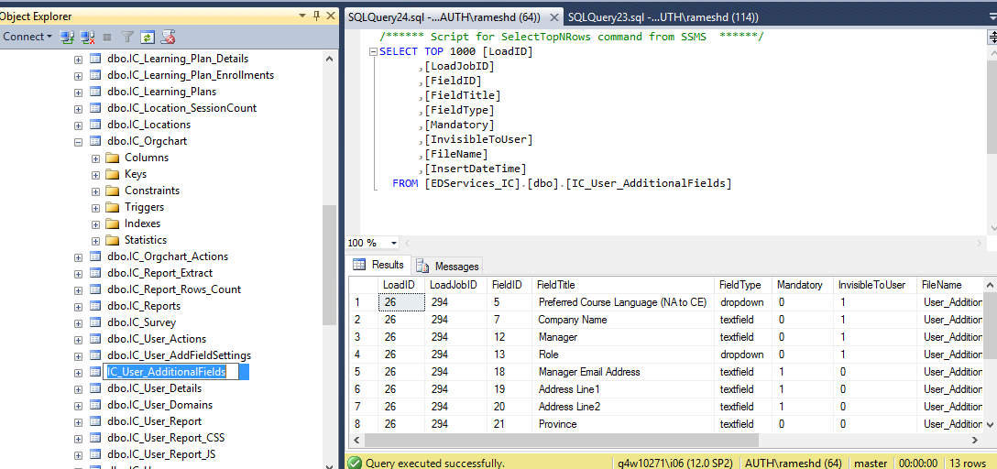

# Learn API

## /**learn/v1/location**

### Data creation in Docebo

**Location creation in Docebo:** Login to Docebo and add new location->Navigate to Classroom->Locations->Add new location

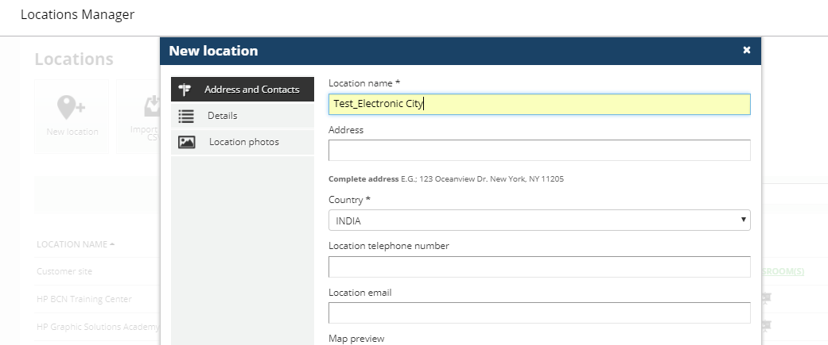

Edit Location-> Navigate to Classroom->Locations->Edit location

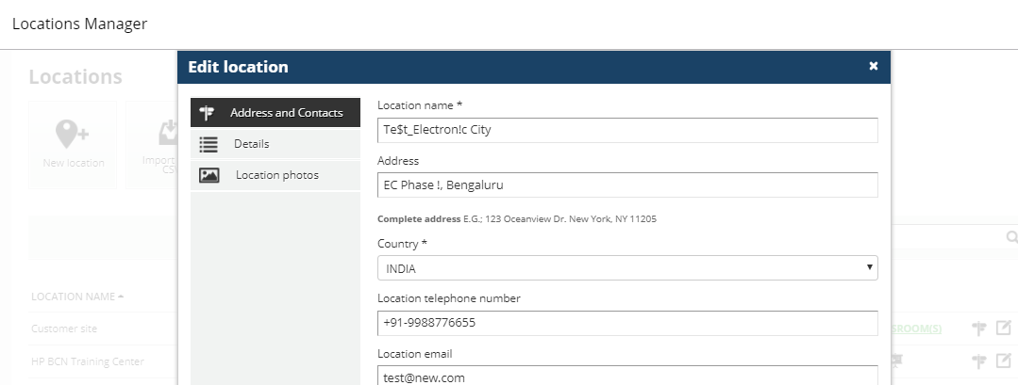

### **API Validation**

Validate /learn/v1/location API response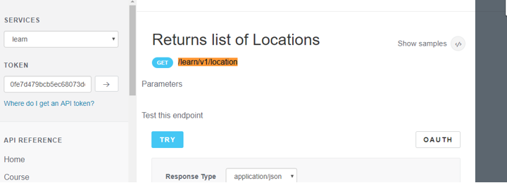

**API Response**

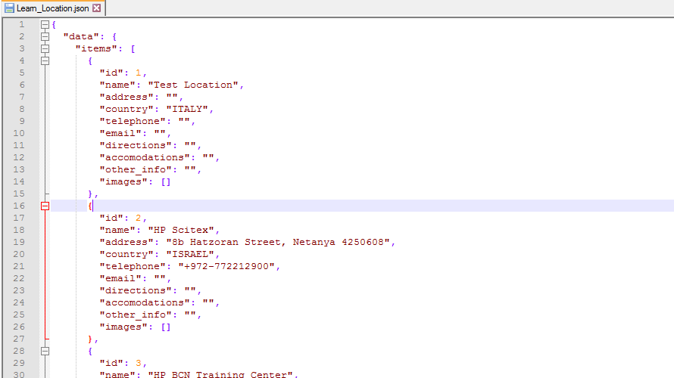

### **Database Validation**

Validate the record in [EDServices_IC].[dbo].[IC_Locations] table

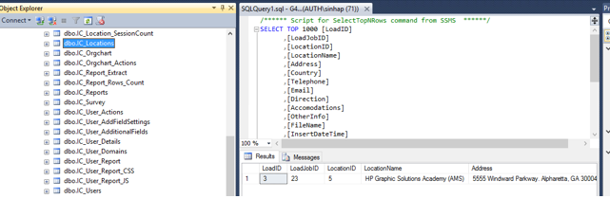

|  |  |  |
| --- | --- | --- |
| **Sl No** | **API List** | **Hlink_Action** |
| 1.2 | learn | /learn/v1/courses |

**Course creation/edition in Docebo:** Navigate to Classroom->Courses->Add/Edit course

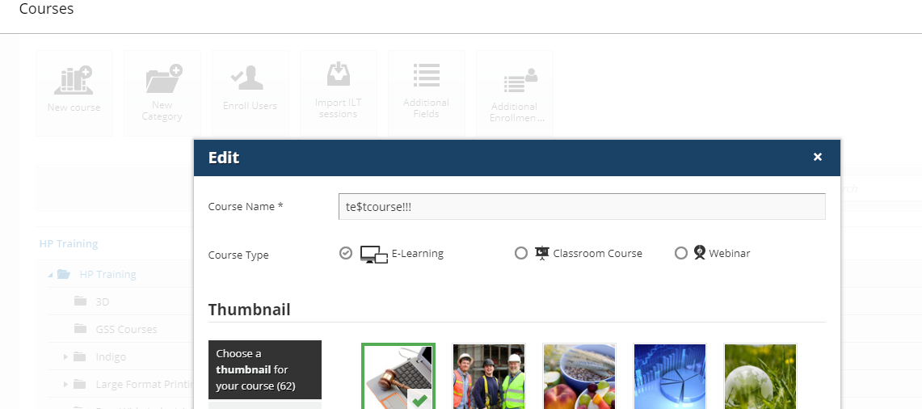

**API Screenshot**

Validate /learn/v1/courses API response

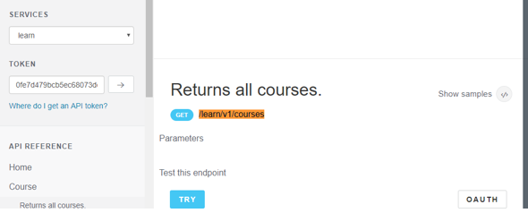

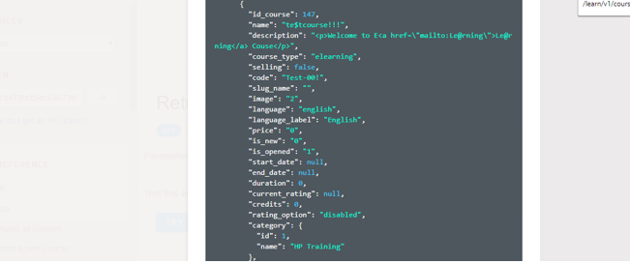

**Database Validation**

Validate the record in [EDServices_IC].[dbo].[IC_Courses] table

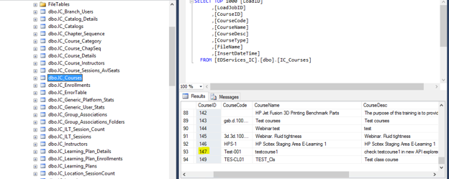

|  |  |  |
| --- | --- | --- |
| **Sl No** | **API List** | **Hlink_Action** |
| 1.3 | learn | /learn/v1/courses/{course_id} |

**Course creation/edition in Docebo:** Navigate to Classroom->Courses->Add/Edit course



**API Validation**

Validate /learn/v1/courses/{course_id} API response by providing valida course id

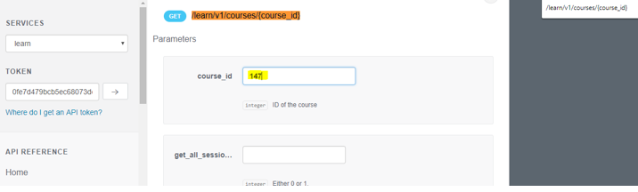

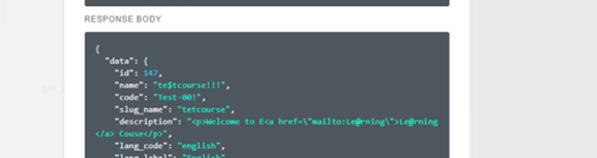

**Database Validation**

Validate the record in [EDServices_IC].[dbo].[IC_Course_Details] table

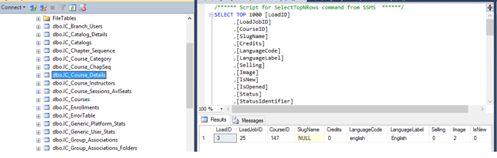

|  |  |  |
| --- | --- | --- |
| **Sl No** | **API List** | **Hlink_Action** |
| 1.4 | learn | /learn/v1/catalog |

Add/Edit catalog in Docebo: Navigate to Course catalog->Course catalog->Add/Edit catalog

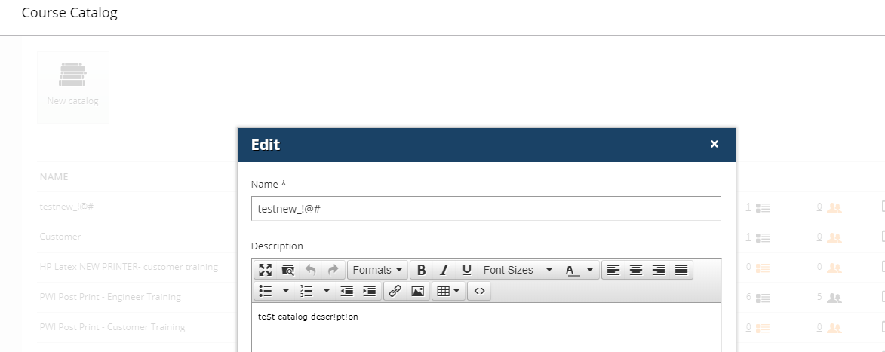

**API Response Validation**

Validate /learn/v1/catalog API response

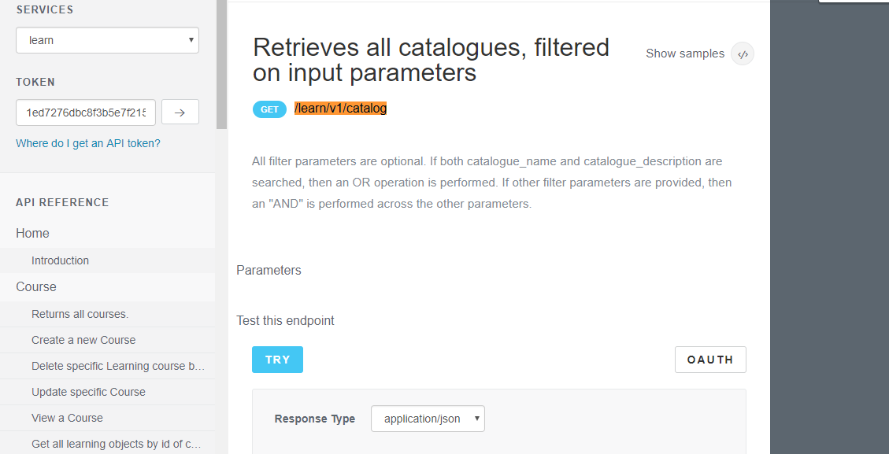

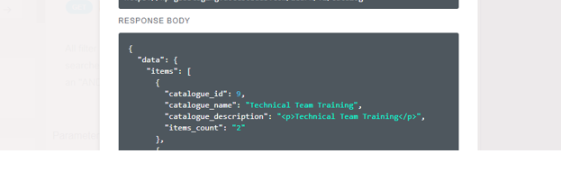

**Database Validation**

Validate the record in [EDServices_IC].[dbo].[IC_Catalogs] table

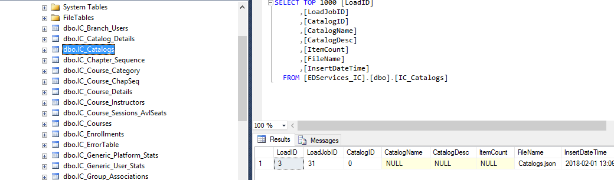

|  |  |  |
| --- | --- | --- |
| **Sl No** | **API List** | **Hlink_Action** |
| 1.5 | learn | /learn/v1/catalog/{catalog_id} |

**Add catalog in Docebo:** Navigate to Course catalog->Course catalog->Add new catalog

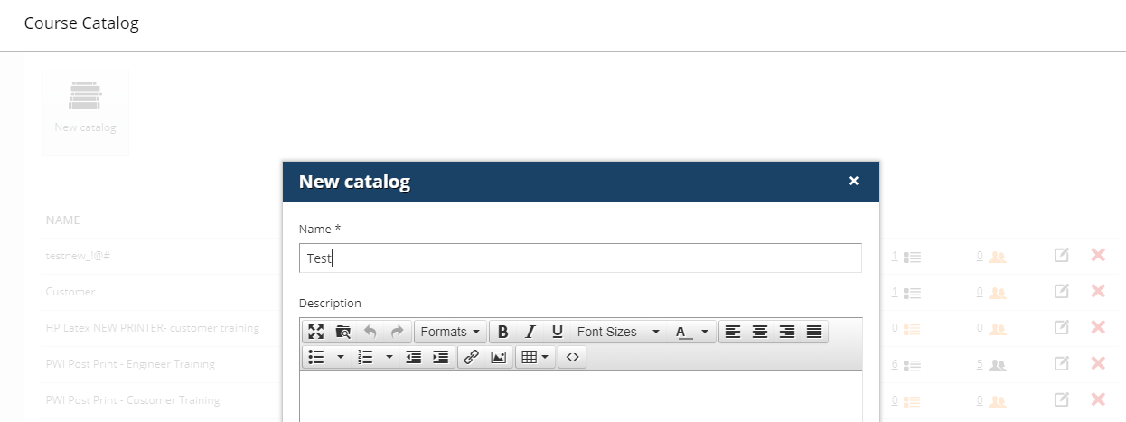

**API Response Validation**

Validate /learn/v1/catalog/{catalog_id} API response

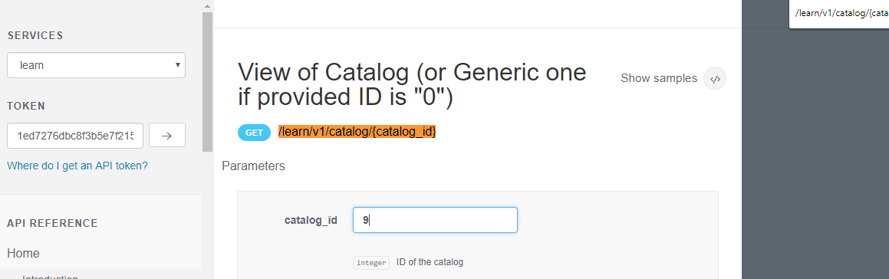

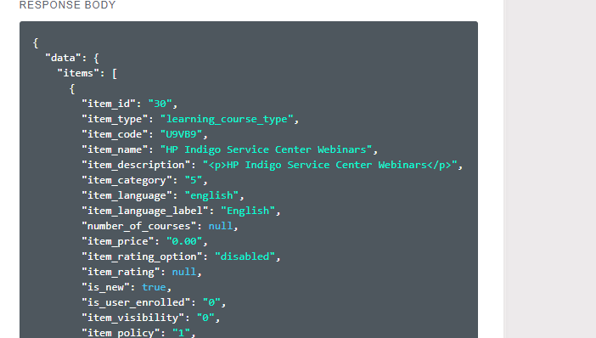

**Database Validation**

Validate the record in [EDServices_IC].[dbo].[IC_Catalog_Details] table

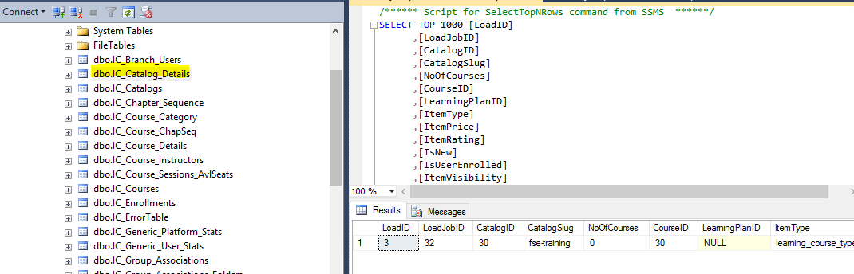

|  |  |  |
| --- | --- | --- |
| **Sl No** | **API List** | **Hlink_Action** |
| 1.6 | learn | /learn/v1/lp |

**Create Learning plan in Docebo:** Navigate to Learning Plan->Manage->add new learning plan

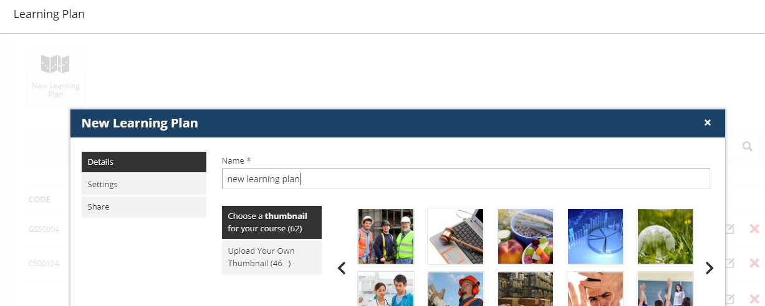

**API Response Validation**

Validate /learn/v1/lp API response

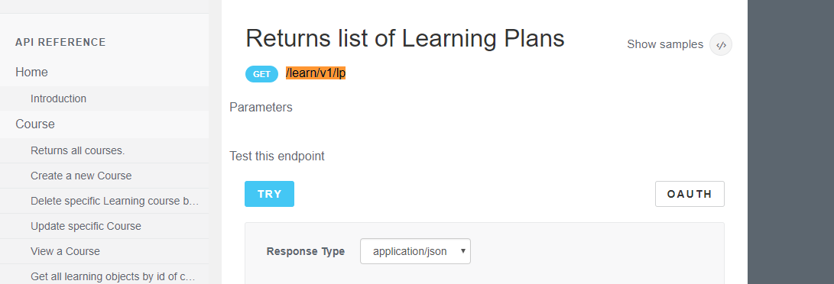

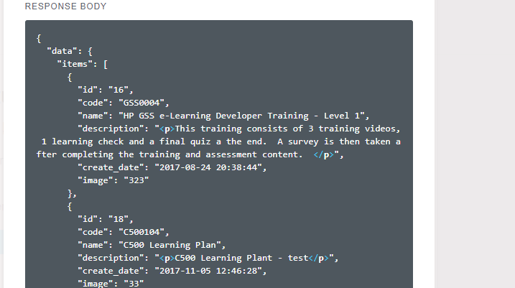

**Database Validation**

Validate the record in [EDServices_IC].[dbo].[IC_Learning_Plans] table

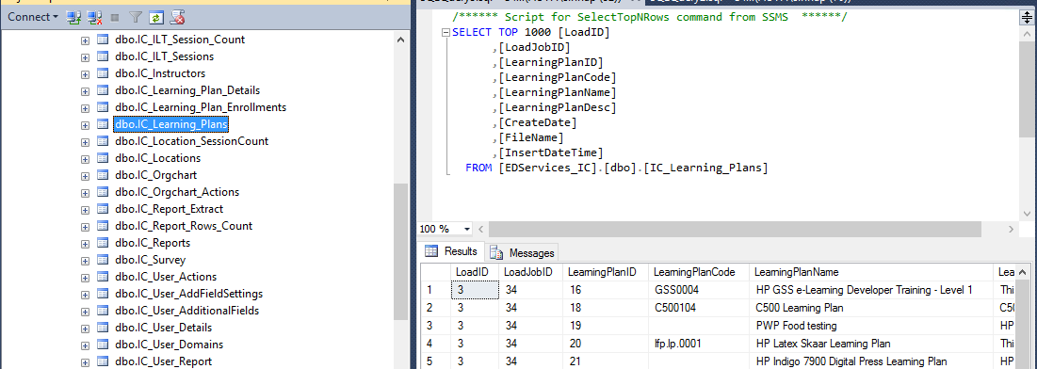

|  |  |  |
| --- | --- | --- |
| **Sl No** | **API List** | **Hlink_Action** |
| 1.7 | learn | /learn/v1/lp/{lp_id} |

**Edit learning plan in Docebo: Navigate to Learning Plan->Manage->Edit learning plan**

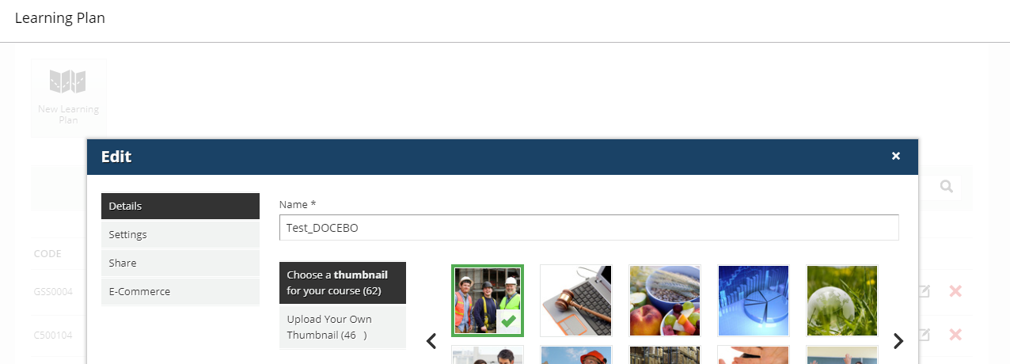

**API Response Validation**

Validate /learn/v1/lp/{lp_id} API response

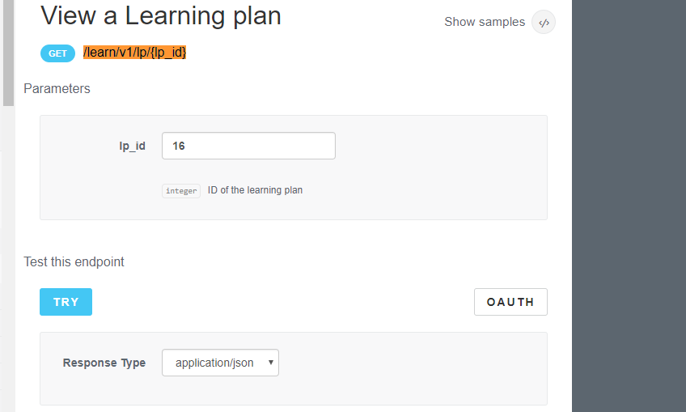

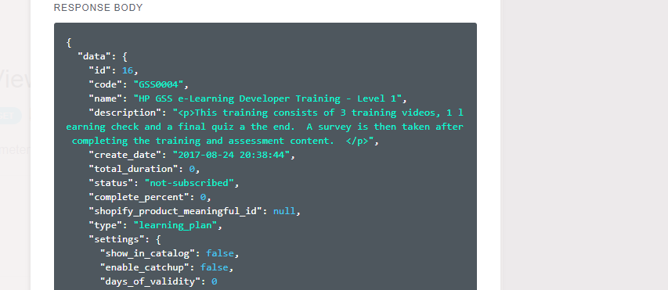

**Database Validation**

Validate the record in [EDServices_IC].[dbo].[IC_Learning_Plan_Details] table

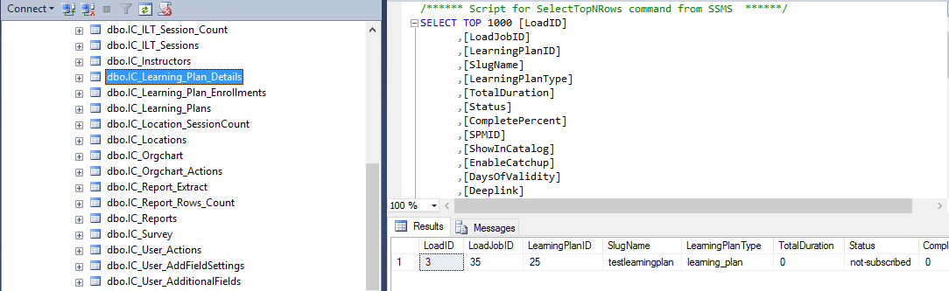

|  |  |  |
| --- | --- | --- |
| **Sl No** | **API List** | **Hlink_Action** |
| 1.8 | learn | /learn/v1/enrollments |

**Enroll a course in Docebo:** Navigate to Courses->Add new E-learning course and Enroll the user to the course

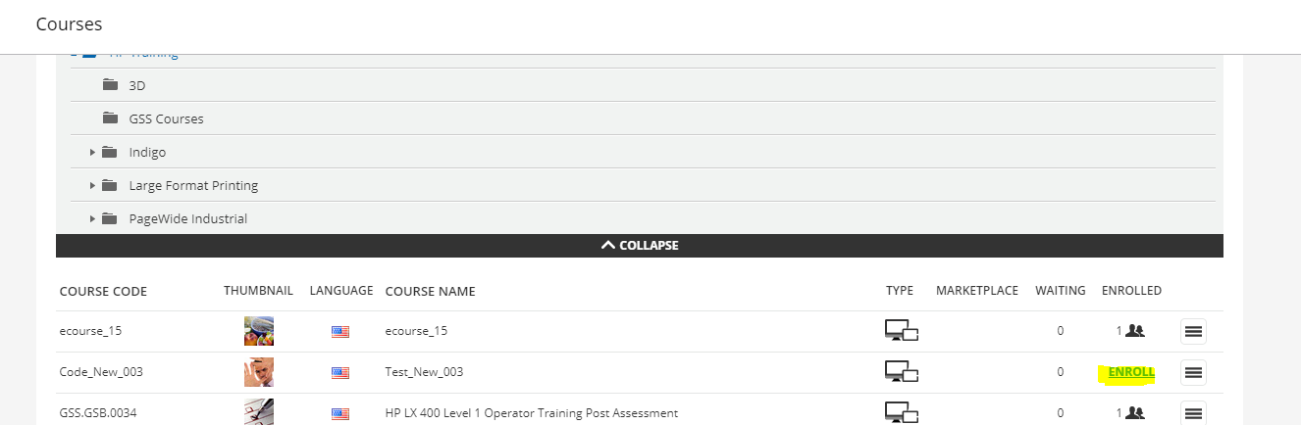

**API Response Validation**

Validate /learn/v1/enrollments API response

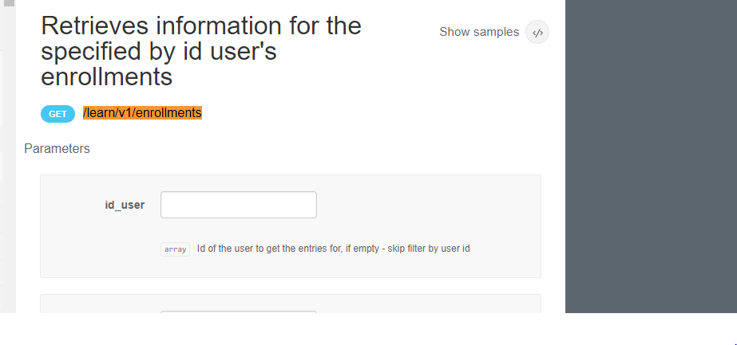

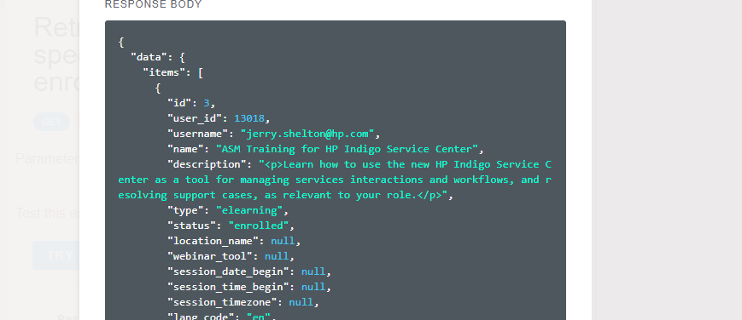

**Database Validation**

Validate the record in [EDServices_IC].[dbo].[IC_Enrollments] table

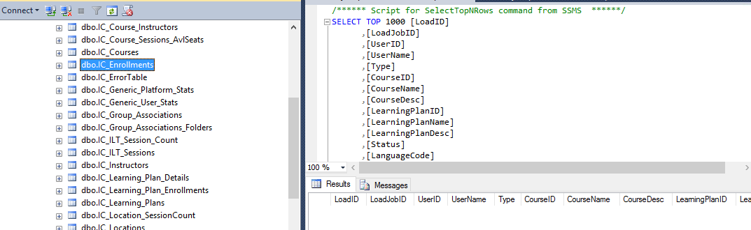

|  |  |  |
| --- | --- | --- |
| **Sl No** | **API List** | **Hlink_Action** |
| 1.9 | learn | /learn/v1/survey/[object_id]/answer |

**API Response Validation**

Validate [/learn/v1/survey/{id_object}/answer](https://hp-gsbstaging.docebosaas.com/api-browser/#!/learn/Survey/Survey_learn_v1_survey_id_object_answer) API response

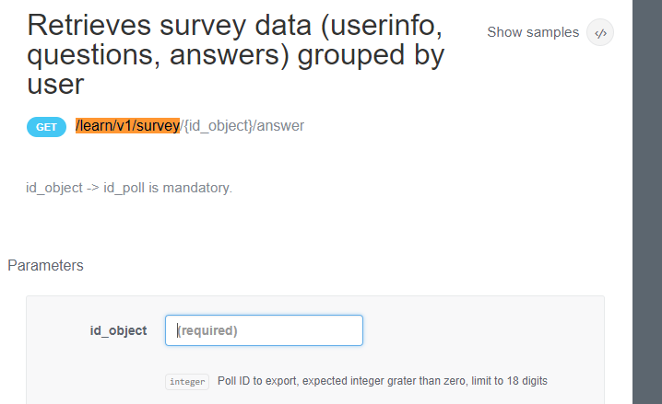

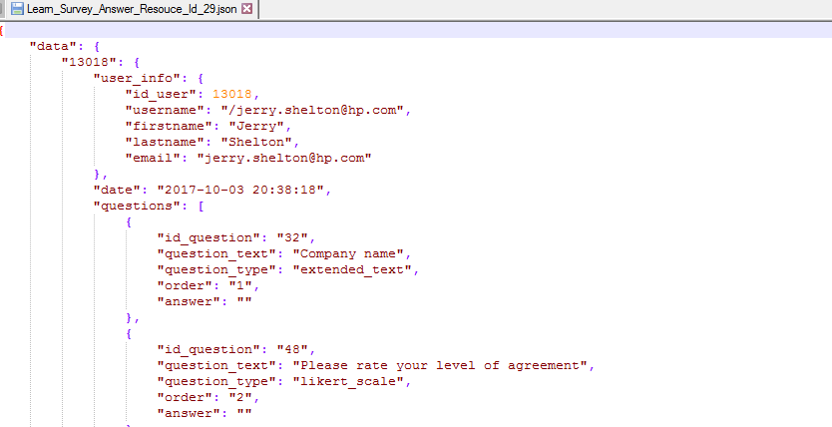

**Database Validation**

Validate the record in [EDServices_IC].[dbo].[IC_Survey] table

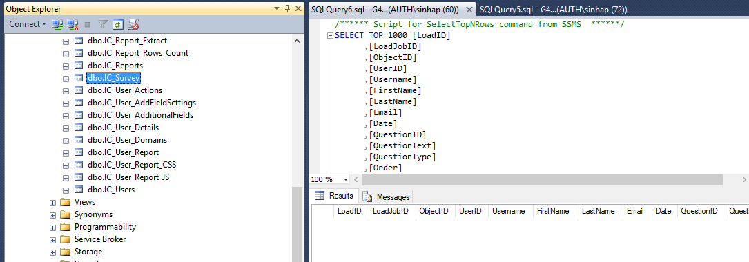

# Docs API

## /iltsessions/listAction

### **API Response Validation**

Validate /iltsessions/listAction API response

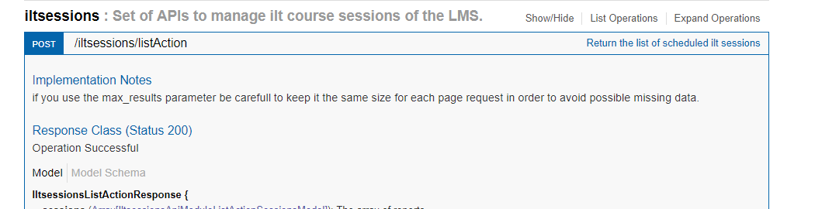

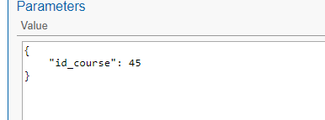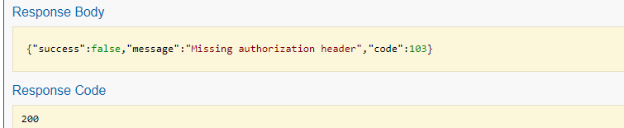

### **Database Validation**

Validate the record in [EDServices_IC].[dbo].[IC_ILT_Sessions] table

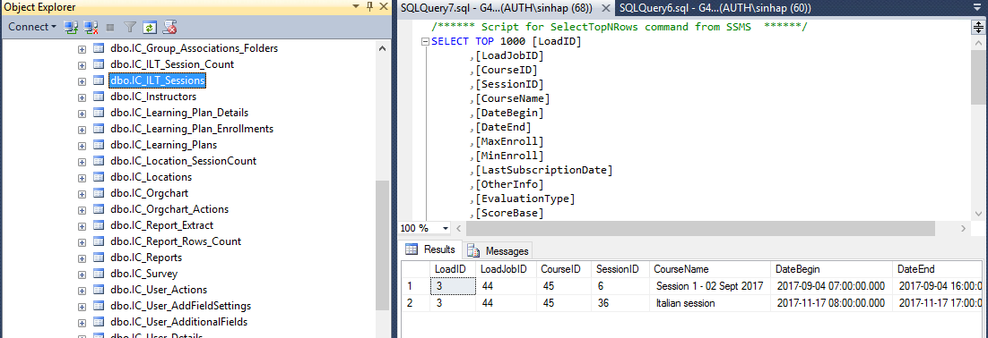

## /iltsessions/ilt_course_status_count

### **API Response Validation**

Validate /iltsessions/ilt_course_status_count API response

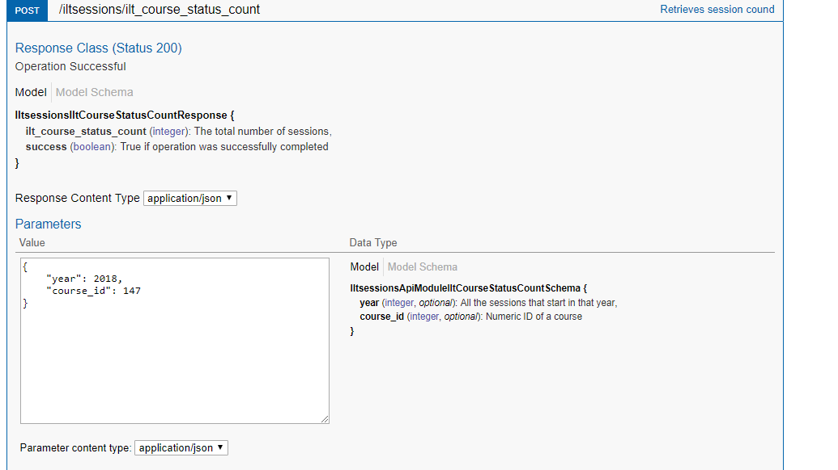

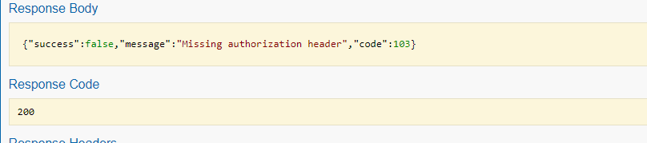

### **Database Validation**

Validate the record in [EDServices_IC].[dbo].[IC_ILT_Session_Count] table

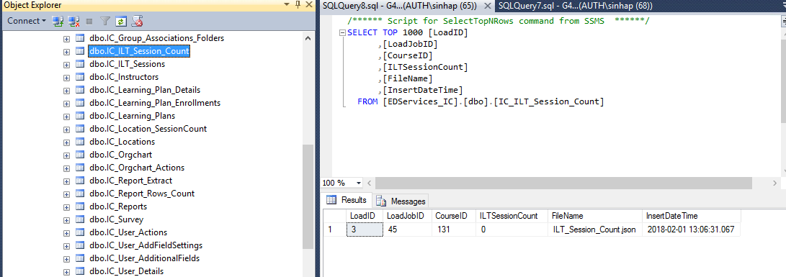

## /location/countSessionsByLocation

### **API Response Validation**

Validate /location/countSessionsByLocation API response

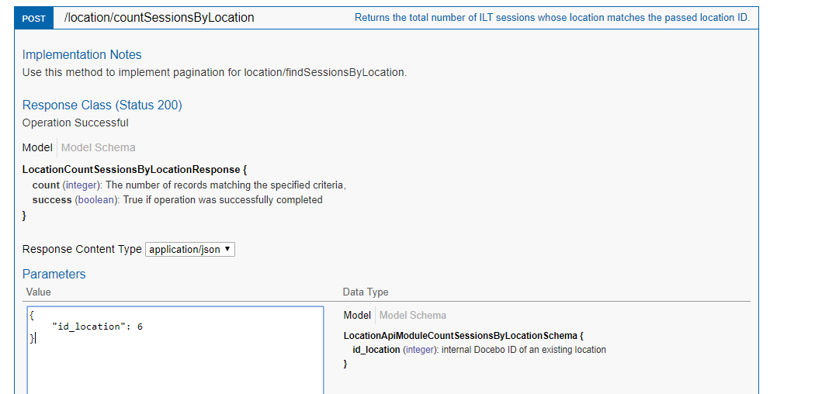 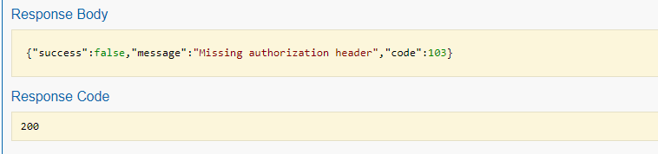

### **Database Validation**

Validate the record in [EDServices_IC].[dbo].[IC_Location_SessionCount] table

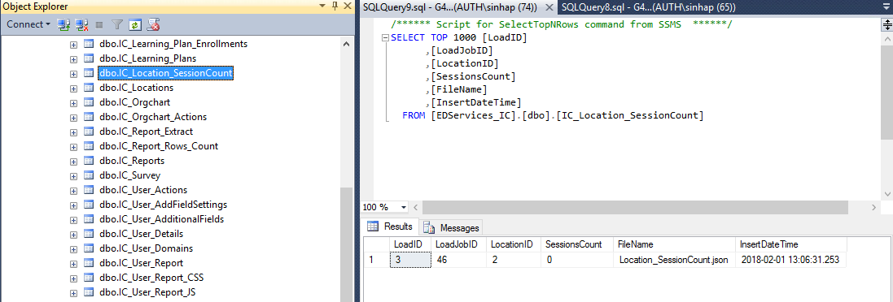

## /learningplan/enrollments

### **Data creation in Docebo:**

Navigate to Learning Plan->Manage->Add new Learning plan and enroll new users

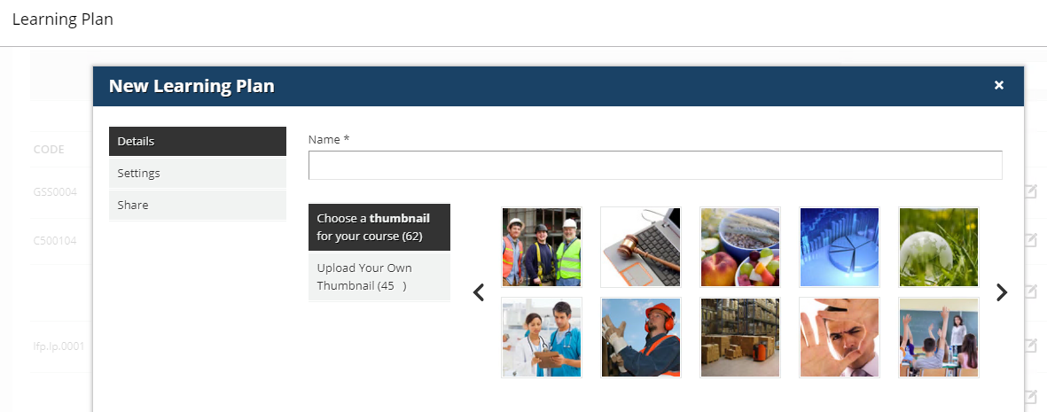

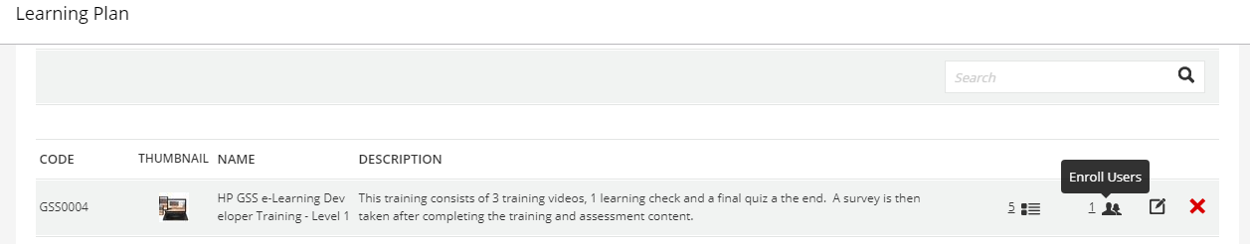

### API Validation

Navigate to Learning plan->learningplan/enrolment, hit try button and verify the newly created learning plan and enrolled user are displayed in response correctly

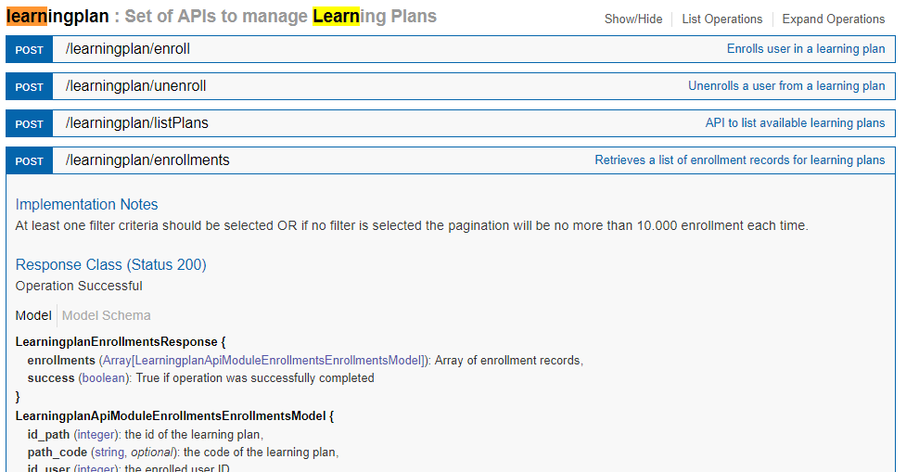

Sample apl response



### Database validation

Login to server in SSMS and validate the records in [EDServices_IC].[dbo].[IC_Learning_Plan_Enrollment] table

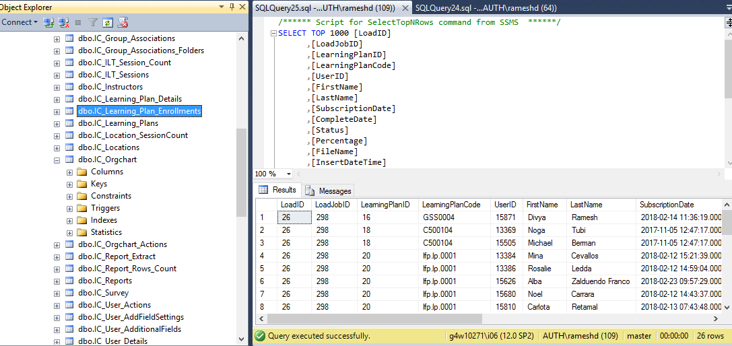

## /report/listReports

### **Data creation in Docebo**

Navigate to Settings->Report and add a new report and fill what details need to be extracted and title of report

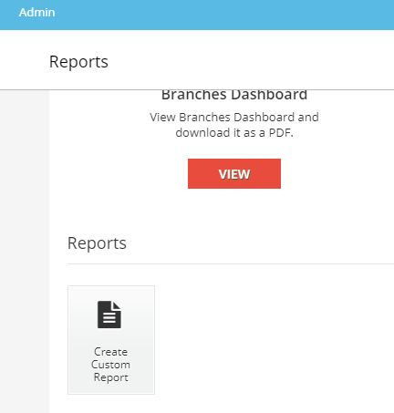

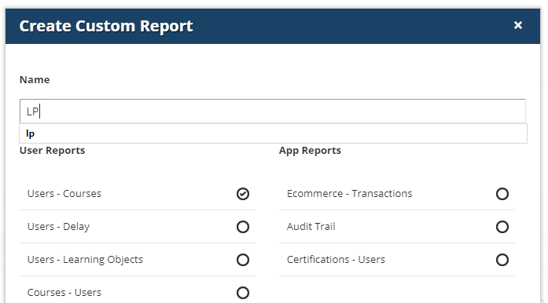

API validation:

Login with valid authentication token in API testing tool and Search for "Report"->/report/list Reports. Try it

Validate the newly created report is available in response

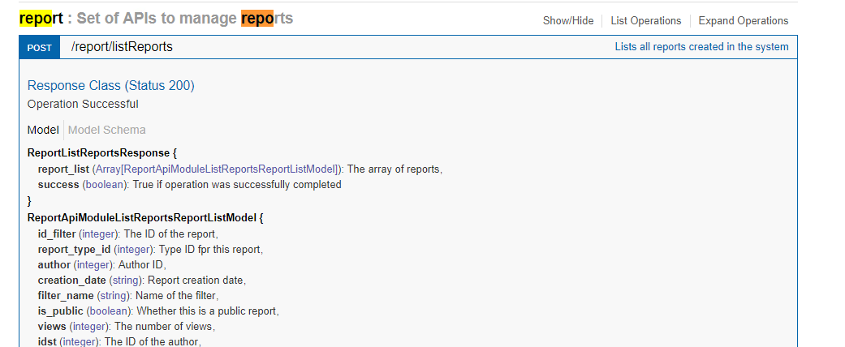

Sample response



### **Database validation**

Login to server in SSMS and validate the records in [EDServices_IC].[dbo].[IC_Reports]table

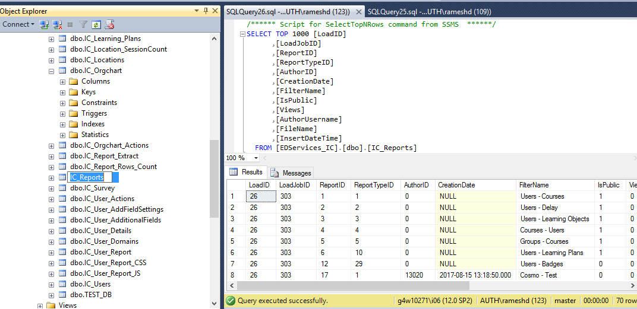

## /report/user

### API Validation

Search for "Report"->Report/user, Enter proper user id and Hit Try button and validate the data

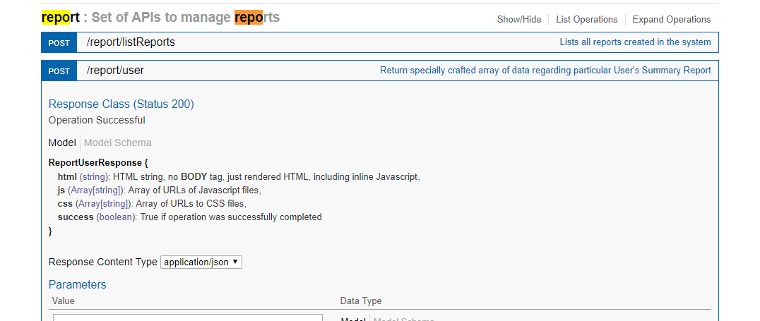

Sample response



### **Database validation**

Login to server in SSMS and validate the records in [EDServices_IC].[dbo].[IC_user_Reports]table

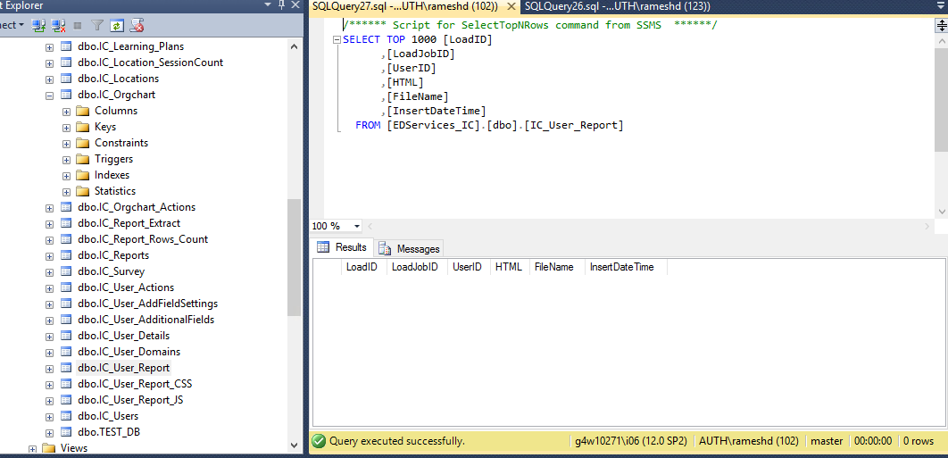

## /report/countRows

### **Data creation in Docebo**

Navigate to Settings->Report and add a new report and fill what details need to be extracted and title of report.

Open the report and Verify and note down the created report rows count





### API Validation:

Search for "Report"->/report/count Rows, Hit Try button with valid report id and validate the data

Verify the count of rows reflected in Docebo UI and Api and database matched

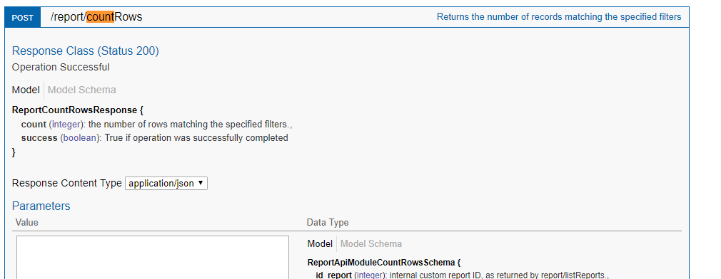

Sample response



### Database validation:

Login to server in SSMS and validate the records in [EDServices_IC].[dbo].[IC_Report_Rows_Count]]table

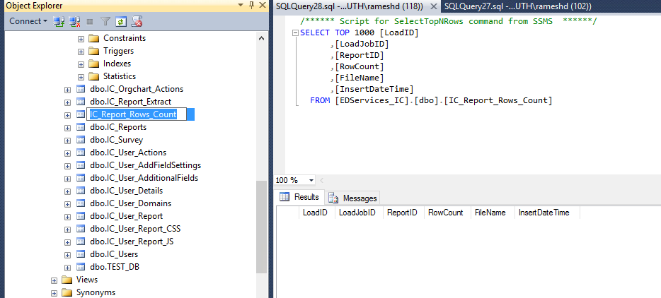

## /report/ExtractRows

### **Data creation in Docebo**

Navigate to Settings->Report and add a new report and fill what details need to be extracted and title of report.

Open the report and Verify and note down the created report details with header and data





### API Validation:

Search for "Report"->/report/extract Rows, Hit Try button with valid report id and validate the data

Verify the rows reflected in Docebo UI and Api and database matched

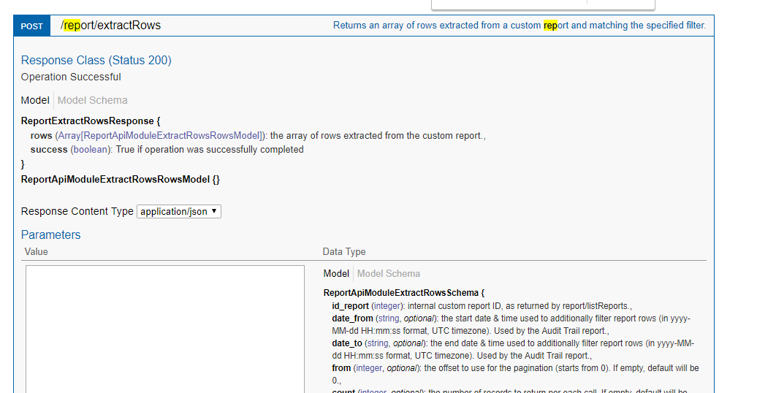

Sample response



### Database validation:

Login to server in SSMS and validate the records in [EDServices_IC].[dbo].[IC_Report_Extract] table

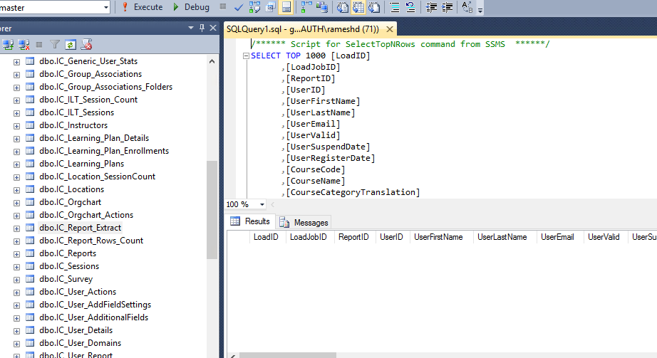

## /stat/getGenericUserStat

### API Validation:

Search for "stat"->/stat/getGenericUserStat, Hit Try button and validate the data

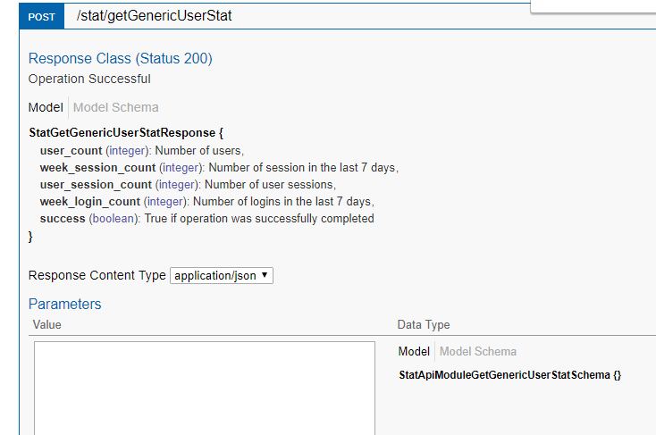

Sample response



### Database validation:

Login to server in SSMS and validate the records in [EDServices_IC].[dbo].[IC_Generic_User_Stat] table

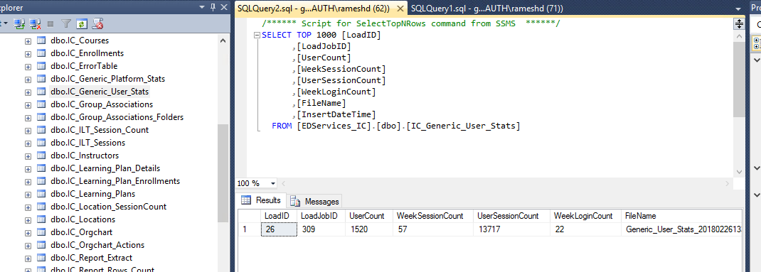

## /stat/getGenericPlatformStat

### API Validation:

Search for "stat"->/stat/getGenericUserStat, Hit Try button and validate the data

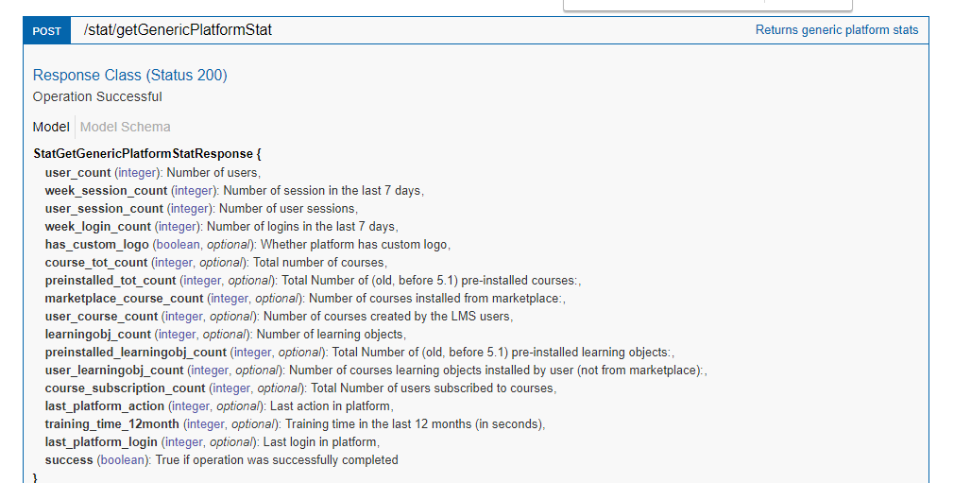

Sample response



### Database validation:

Login to server in SSMS and validate the records in [EDServices_IC].[dbo].[IC_Generic_Platform_Stat]table

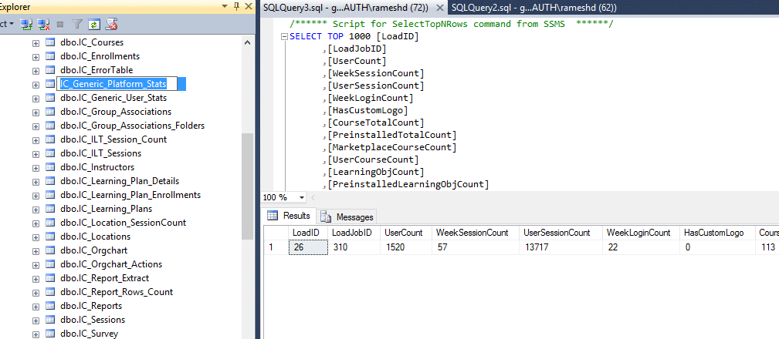

## /stat/getGenericUserStat

### API Validation:

Search for "stat"->/stat/getGenericUserStat, Hit Try button and validate the data



Sample response



### Database validation:

Login to server in SSMS and validate the records in [EDServices_IC].[dbo].[IC_Generic_User_Stat] table



## User/group_association

### Data creation in Docebo

Navigate to settings->User , enroll user to Multiple group

### API Validation:

Search for "user"->/user/user/group_assocaition, Hit Try button with valid user id and validate the response is showing the user mapped to particular group.

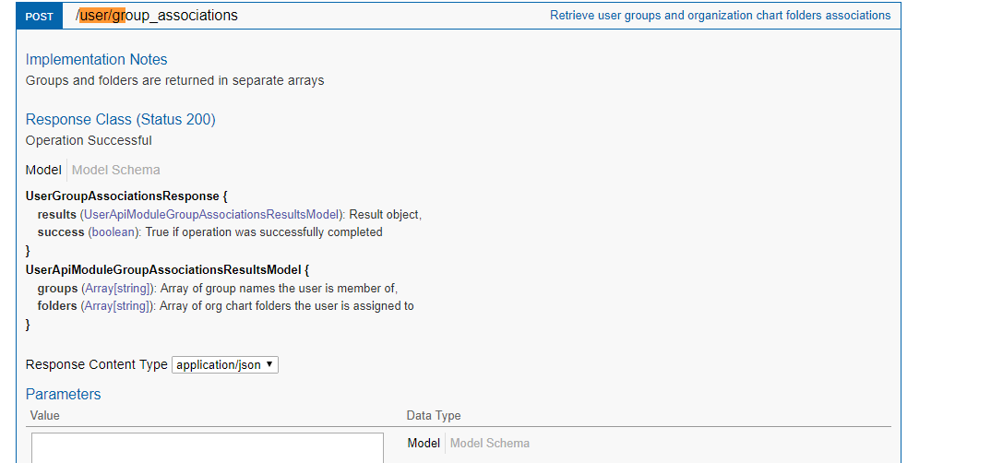

Sample response



### Database validation:

Login to server in SSMS and validate the records in [EDServices_IC].[dbo].[IC_Group_Associations] table

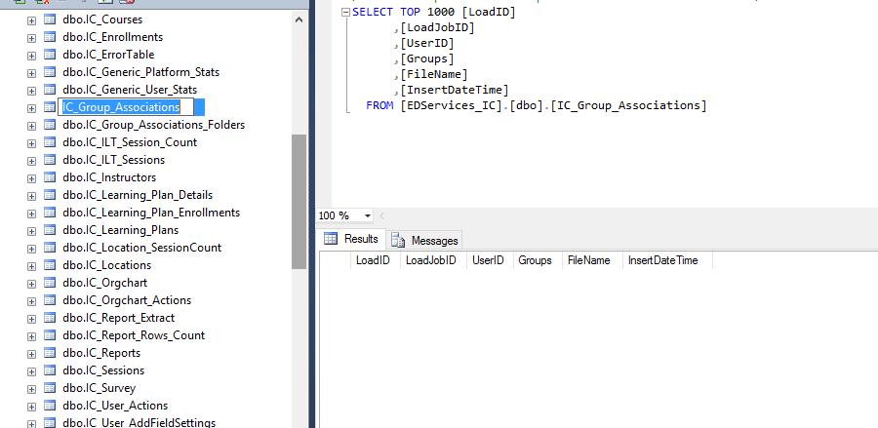

# Additional Information

ALM is maintained for Test case and Defect tracking. We have uploaded the test case with detail steps. You can find the same

